Palimpsest Project – Dreaming Urban Nature

A residency in Flock House Project Omaha
Bemis Center for Contemporary Arts – Old Market

Prepared by Cynthia P. Gehrie, Ph.D. – project leader
Botanical Artist and Qualitative Researcher in Arts Integration Programs
Volunteer Coordinator with the Iowana Farm CSA
August 6 – 16, 2014

The Palimpsest project used a dual approach integrating research and art making. I led it with several volunteers from the Iowana Farm CSA (Community Supported Agriculture) in Crescent, Iowa.

Research

After meeting with Alex Priest and Mary Mattingly I designed a mini-studio inside the New York City Flock House, which was part of Flock House Omaha Project. I worked with Alex to place drawing boards, pens, pencils, and markers that visitors used to complete 7 Questions about the idea of Flock House, and to draw their vision of Flock House. Index cards, scissors and tape were included for visitors who preferred to make a model.

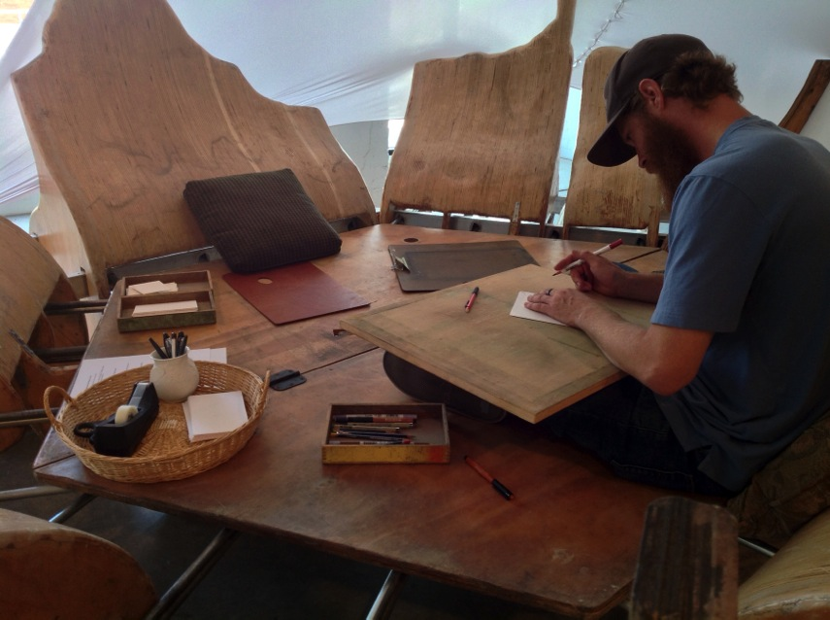
Figure 1 - Tyler Kissel, an Omaha artist, draws his concept for a Flock House. He said, "I want one in my backyard." He introduced the idea of moveable gardens.

Sixty visitors answered the 7 Questions. They also created a drawing or a model. The entire collection of drawings, models and responses to the 7 Questions are posted in my online journal at http://www.harveststudioonline.com/journal

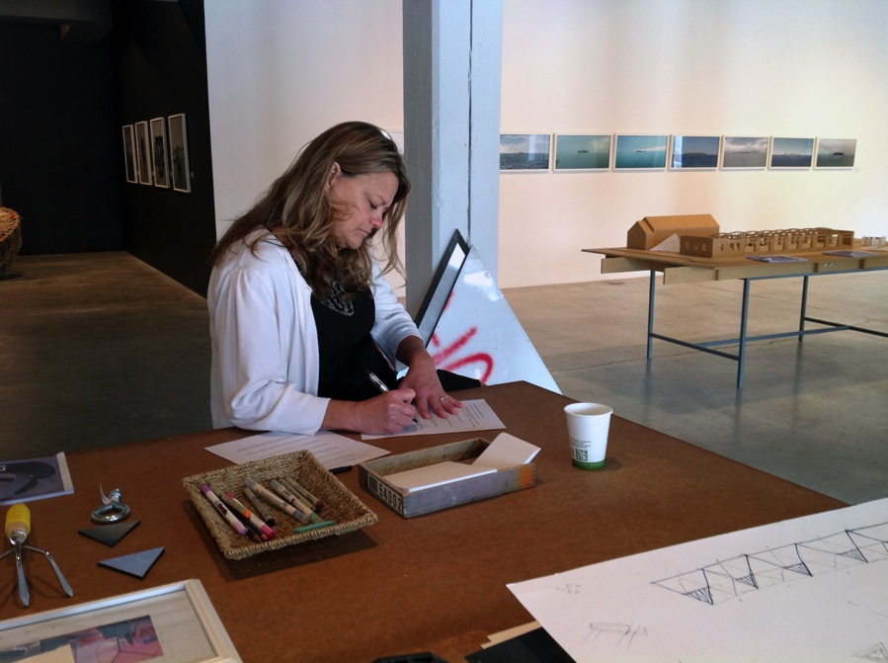
Figure 2 - April Earl, librarian at Omaha Public Library, completes 7 Questions. "What a peaceful place to work," she said looking around the Flock House exhibit, which offers room for study and sketching. April was one of the first volunteers at Iowana Farm.
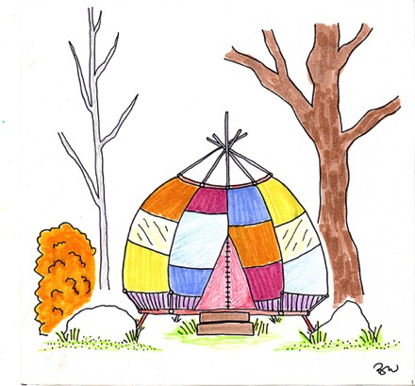
Our project team discovered that the idea of Flock House is extremely attractive to visitors. They associate Flock House positively to a variety of structures from their prior experience such as camping in tents, covered wagons, and playground equipment.
Figure 3 - Flock House in natural area, far from the city.

Nearly all the visitors wanted to spend time in a Flock House! However, most envisioned it in a natural area, in respite to their urban lives.

The idea of a Flock House as a conduit for a more natural, gardened urban space did not communicate in the Flock House exhibit. Therefore, my colleagues and I focused on exploring how to create the idea of urban natural areas and food gardens that are enhanced by temporary Flock House structures. As we began to draw compositions, we started to think of ourselves as Dreaming Urban Nature.

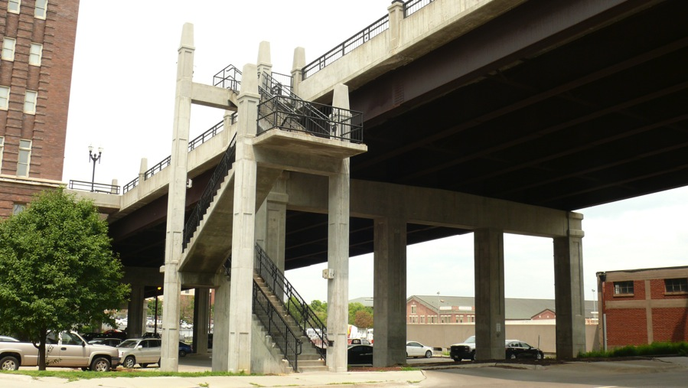
Figure 4 - This space under 10th Street, a block from Bemis Center for Contemporary Arts, has a staircase and pillared understructure perfect for vertical gardens.
Another stage of research involved searching for spaces in the Metropolitan area to inspire conversations about transforming abandoned space into natural gardens and creative centers. This stage was guided by Kelly Klempfer and informed by Chris Wiskus from Council Bluffs, Iowa who have volunteered at Iowana Farm for several years.

Art Making: August 6 – 16, 2014

Art making included mini-residencies by volunteers who worked on a rain chain for the Bemis Center Flock House, papermaking from recycled paper and fabrics, and a bicycle food cart and painting of The Urban Homestead. A community yoga and music evening was led by Karen Bahr. It focused on the concept that more natural urban spaces will require bonded communities with capacity to create together. Video clips of these activities are on the Flock House Project Omaha at Tumblr.com website http://flockhouseomaha.tumblr.com

Ongoing in the Flock House residency, I led volunteers and visitors in making Palimpsest compositions.

Three compositions in the Palimpsest project began with a photograph of an ignored or an abandoned site, left to degrade. The fourth is a Palimpsest composition of project icons and text naming its process, “Dreaming Urban Nature.”

Potential photos included the 10th street overpass, a swing bridge over the Missouri River constructed in 1905, an abandoned grain elevator, abandoned railroad tracks, an abandoned airport parking lot, and the recently closed Griffin Pipe Products building in Council Bluffs.

I set up each composition with an ink line drawing of one of these places. Then I added a second layer using block prints that were icons for the project. Volunteers joined in to develop new layers by designing, drawing and painting elements of urban nature. Primarily they used artisan black walnut ink with soft and oil pastels.

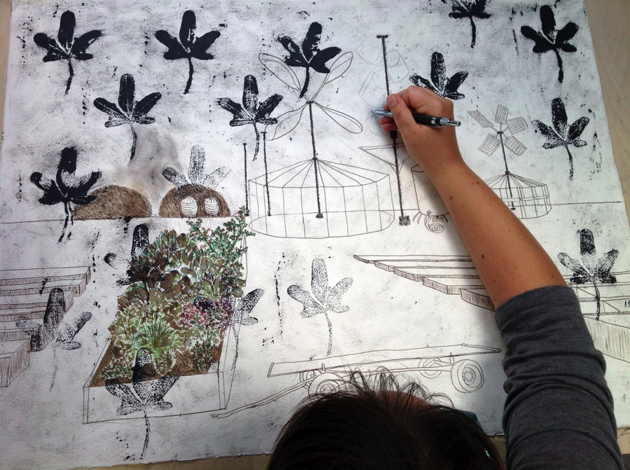
Figure 5 - Composition I: Green Go. Octavia Butler, a schoolteacher at Gomez Heritage Elementary School in Omaha, draws her rain chain design to capture rainwater and store it in a tank next to the rain chain pole.
I. Starting with a photo of an abandoned parking lot, a pencil drawing of the parking lot was inked in. Next, a new layer of block prints was superimposed. The prints are the emblem of the Palimpsest Project. It is an imaginative block print of a 5-leaf cluster from antiquity, which eventually merged into the Maple Leaf. It is a symbol of multiple images, which integrate over time into one complex representation. Palimpsest.

Several volunteers from Iowana Farm populated the parking lot with movable planting beds, a wagon for moving the beds into new growing areas, seedling greenhouses built out from the original parking light poles, compost conversion and storage areas, wind energy generators, rain capture storage, and Flock Houses.
The dreaming for this painting envisioned a verdant area replacing a dead zone. Here, seeds become plants, and plants are established in movable beds that will be taken to growing areas where they mature into fully formed gardens.

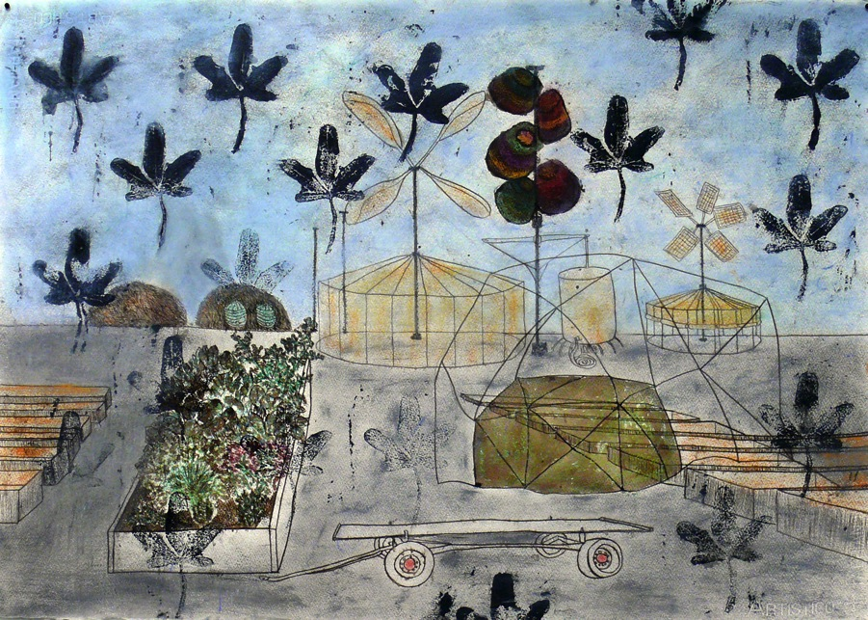
Figure 6 - Green Go Composition. The open structure, center right, is based on a Flock House drawing by a 4th grade visitor to the Mary Mattingly exhibit. It has an inner chamber and an outer protective structure.
II. Starting with a photo of the space under elevated 10th street in downtown Omaha, a line drawing of the staircase and supporting pillars was inked in with black walnut ink. A block print was added depicting Flock House as an idea. (See left below)

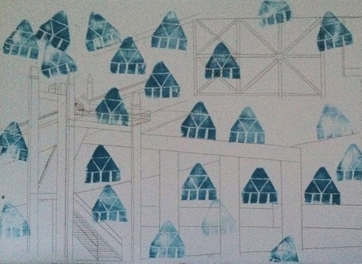
Then Octavia began filling in vertical gardens on the pillar structures supporting 10th street. She also drew in moving gardens that would be relocated to the area overnight.
Figure 7 - Composition II – Green Grow - set up by Cynthia Gehrie
A short video at Flock House Omaha, Tumblr.com shows Kate’s design in an elevation drawing of vertical space surrounding a giant staircase connecting 10th street to ground level.

First she visited the actual staircase and studied it. She devised a system of planters that moved up the staircase, leaving framed openings, which volunteers could use to access the vertical beds.
To develop her idea, she drew an elevation of the staircase above the perspective drawing. Once it was complete, she used it to place vertical growing areas within the perspective drawing. Then she added planters and plants in both the elevation and perspective drawing.

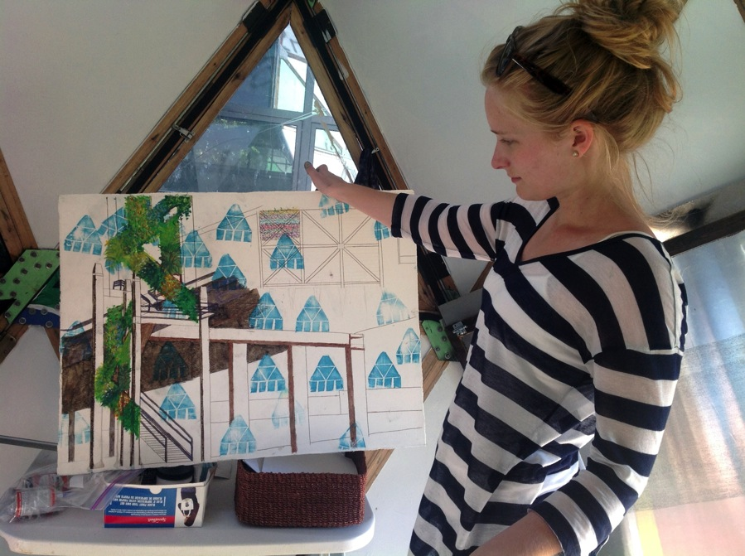
Figure 8 - Kate Giersch, now in her residency as a physician's assistant, designed an elevation drawing to work out the perspective line drawing of a vertical staircase garden.
Dirk, a Bemis neighbor visited the Flock House and stayed to add moveable planting beds beneath the overpass.

The dreaming for this painting centered on the need for Omaha residents to enlarge their understanding of urban gardens beyond limited community gardens and a few roof gardens, to include vast vertical gardens throughout the city and metropolitan area.
Like the circus coming to town, we dreamed of movable gardens, fully grown, suddenly appearing in sites set up overnight, greeting residents by morning light. Inviting them to visit, photograph and post on social media, buy produce and flowers. They might even get their exercise by riding a row of bicycles that generate power for the garden. How fun would that be! How fun is dreaming.

III. Starting with a photo of abandoned railroad tracks with wide spaces of open land, a line drawing of the tracks was used to divide the paper into a growing area surrounding the tracks and the sky above. These were populated with small prints lifted from the blocked areas in the first two compositions, before new painting layers were added. Cassidy’s hand made papers were cut to form Flock Houses.
The concept was to locate moving gardens into empty spaces, to be cared for by volunteers. Movable Flock Houses, built by volunteers using recycled materials, provide shelter and material storage.
Additional Flock Houses offer creative spaces that volunteers can reserve for short periods to pursue their own creative work.
Dreaming for this painting focused on places where moveable gardens could develop before they are transferred to Circus sites in urban locations.

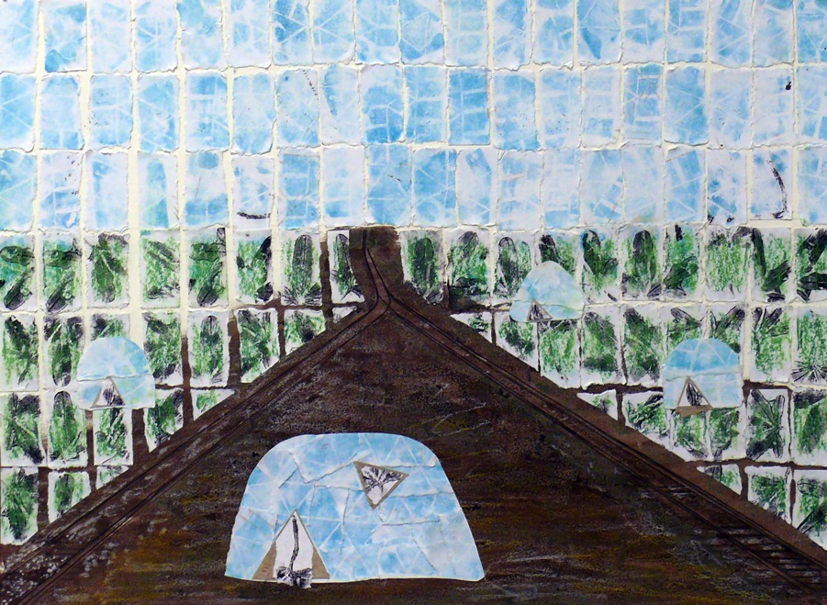
Figure 9 - Green Grow, Railroad Location combines a site where moveable gardens can grow around Flock House structures which volunteers, caring for the gardens, can reserve for their own creative endeavors.
IV. The fourth composition, Drawing Urban Nature, is a Palimpsest composition in four layers. Layer one is distributed Block Prints of the Palimpsest Project 5 leaf image. Layer two sprinkles the Flock House Block icon across the paper. Layer three groups card stock rectangles that are marked with lifted images from the Block Prints.

A short video clip shows Brad and Eleanor Wissmueller, Iowana Farm CSA volunteers, positioning lift print rectangles across the composition. They intuit how their accidental markings mirror and marry with one another to form strings of images. (See Flock House Omaha, Tumblr.com)

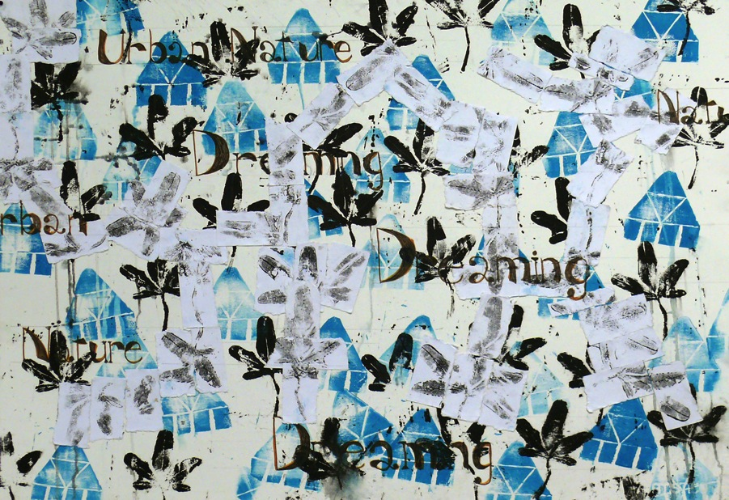

The final layer buries lettering beneath the rectangles but over the block prints, so that they peek out from and disappear behind the paper rectangles. The words are Dreaming Urban Nature. This describes a process of engagement, which evolved within the Palimpsest Project.

Exhibit – Bemis Center for Contemporary Arts – Old Market, Omaha
August 16 – September 20, 2014

“We see Flock House as a creative atmosphere where urban space is reimagined. Palimpsest composition is used to record dreams that return nature to urbanity. The dream began with photos of abandoned or hidden areas, the discarded or overlooked. The Palimpsest team is primarily populated by volunteers from the CSA (Community Supported Agriculture) at Iowana Farm in Crescent, Iowa”
Cynthia Gehrie, project leader

Summary

We found that making these compositions supported our inquiry into naturally gardened urban spaces. All of us began to report that when we saw dead, empty, naked urban spaces around us, we mentally began converting them into gardened areas. We also became more conscious of possibilities for recycling and re-purposing urban spaces as we moved around the metropolitan area. We found the project actually changed the way we perceived urban landscapes. It led us to constantly revise them into urban gardens of every sort.

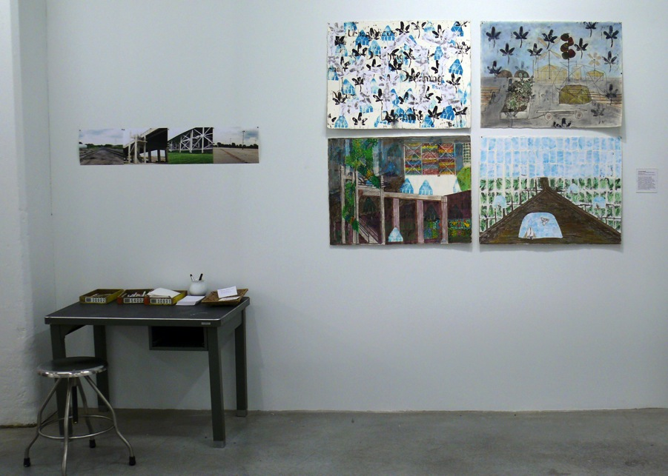
Figure 10 - Flock House exhibit at Bemis Center for Contemporary Arts includes inspirational photos, Compositions, and a drawing space for visitors to respond to the ideas of Green Go and Grow in urban spaces.
We frequently spoke together of the role of “stuff” in our lives. We pondered Mary Mattingly’s leap into a personal world free of the possessions the rest of us organize our lives around.

Perhaps most important, our CSA volunteers from Iowana Farm in Crescent, Iowa increased community bonding through art making. In addition to our time together at Bemis, the Palimpsest project became a topic of excitement during workdays. Volunteers came with ideas for the project, naming places ripe for conversion to urban gardens.

An important part of our dreaming was the assumption that we were in the first stages of actually finding a space and converting it into a natural, gardened area that would be vertical and horizontal using moveable gardens. We imagined Flock Houses as mobile structures to support the plantings, and also house creative work in crafts, contemporary art and the culinary arts. We entered a mental space of possibility, communicating about it as if actually in the initial stages of making it happen. We came to call this state of mind “dreaming.”

Sometimes, dreams become real, once seeds are planted. One volunteer enrolled in a tiny house-building workshop for 10 days in Vermont. Another entered an architecture program to focus on new forms of sustainable architecture at the University of Nebraska. Another registered for bookmaking and sculpture in her art program because she became more interested in using tools to build art, and in 3-D art. A fourth enrolled full time in the horticulture program at Metropolitan Community College.

Our CSA at Iowana Farm, and our volunteers are now bonded to Bemis Center for Contemporary Arts. Participating in Flock House Project Omaha was a strong experience that led us into the meaning and wonder of Contemporary Art. We now understand that its practice includes us. We have learned how to join into community dynamics within the Contemporary Arts.

We see Bemis as an international center where world-class artists come to pursue their artistic vision. We now attend monthly Art Talk events; and are touched by the residents’ vision and courage. These opportunities are inspiring and valuable. Our volunteer community is stronger. We are looking for ways to extend this connection to our CSA shareholders.

We invite residents and staff at the Bemis Center for Contemporary Arts at Old Market and Carver Bank to visit Iowana Farm gardens, fields, native prairies and oak savanna ridges, in pursuit of their creative work.

Comments by participants

Cynthia-
Thank you for the through reporting on the Flock House journey you took us on this summer. It brought back many warm memories of time spent together musing about the future of living and growing spaces.
At Iowana Farm we see many volunteers who want to grow their own food.
Volunteering is often a learning experience about the "agricultural arts".
For many of the volunteers participating in the Flock House experience helped them explore their own artistic and agricultural dreams. It was fun and exciting.
Thanks so much for including us.

Terry Troxel,
Iowana Farm
Owner/Operator

Check this out! I love it and we should do something.. Not sure what but something.

The Vertical Farm - Dickson Despommier
ISBN: 9780312611392
Publication Date: 2010-10-12
"The vertical farm is a world-changing innovation whose time has come. Dickson Despommier's visionary book provides a blueprint for securing the world's food supply and at the same time solving one of the gravest environmental crises facing us today." Imagine a world where every town has their own local food source, grown in the safest way possible, where no drop of water or particle of light is wasted, and where a simple elevator ride can transport you to nature's grocery store - imagine the world of the vertical farm. When Columbia professor Dickson Despommier set out to solve America's food, water, and energy crises, he didn't just think big - he thought up. Despommier's stroke of genius, the vertical farm, has excited scientists, architects, and politicians around the globe. Now, in this groundbreaking book, Despommier explains how the vertical farm will have an incredible impact on changing the face of this planet for future generations. Despommier takes readers on an incredible journey inside the vertical farm, buildings filled with fruits and vegetables that will provide local food sources for entire cities. Vertical farms will allow us to: - Grow food 24 hours a day, 365 days a year Protect crops from unpredictable and harmful weather Re-use water collected from the indoor environment Provide jobs for residents Eliminate use of pesticides, fertilizers, or herbicides Drastically reduce dependence on fossil fuels Prevent crop loss due to shipping or storage Stop agricultural runoff Vertical farms can be built in abandoned buildings and on deserted lots, transforming our cities into urban landscapes which will provide fresh food grown and harvested just around the corner. Possibly the most important aspect of vertical farms is that they can built by nations with little or no arable land, transforming nations which are currently unable to farm into top food producers. In the tradition of the bestselling The World Without Us, The Vertical Farm is a completely original landmark work destined to become an instant classic

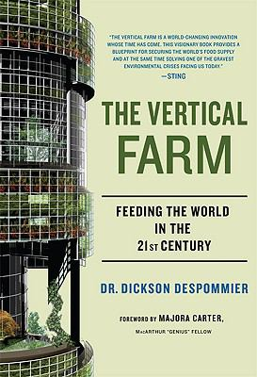
April
April Earl | Book Club Coordinator
W. Dale Clark Main Library 215 S. 15th St. | Omaha, NE 68102
aearl@omahalibrary.org | 402.444.4828
omahalibrary.org

The Flock house got me thinking that in the future we will have to look at alternatives to how we design and build our homes. We can't continue on as we are, the environment presently can't support all that we take from it. I ended up, after visiting the flock house, going on a two-week workshop in home design/build. Yestermorrow Design/Build School (https://yestermorrow.org/) is located in Vermont. They offer many other workshops in natural building and sustainable design. It was well worth the time and expense to take this workshop. I think projects like the flock house inspire one’s thinking outside the box.
Tamara

We simply couldn't be more grateful for the opportunity to be a part of this project. We had so much fun constructing the "prototype" bicycle cart and using pastels to create a scene right out of our dreams. It's not often that we make the time for creative projects and being a part of this made us realize how releasing and healing art can be. Thank you for the opportunity and maybe next time, we can once again be happy contributors.
Lela & Ryan Tunnell

